How to sign a PDF with Adobe Acrobat
(signature drawing, NOT CERTIFIED DIGITAL SIGNATURE)

Sign a PDF.
To sign a PDF document or form, you can type, draw, or insert an image of your handwritten signature. When you save the document, the signature and text become part of the PDF.

Steps to sign a PDF.
- Open the PDF document or form you want to sign.

- Click the Sign icon  in the toolbar. Alternatively, you can choose from the Adobe Acrobat menu: Tools -> Fill & Sign or choose Fill & Sign from the right pane.
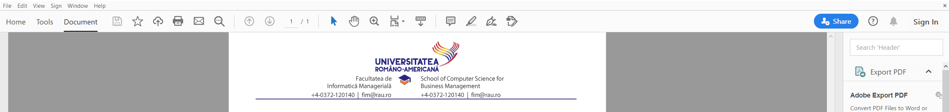

- The Fill & Sign tool is displayed. Change the default black color to blue [1], then click Sign [2].
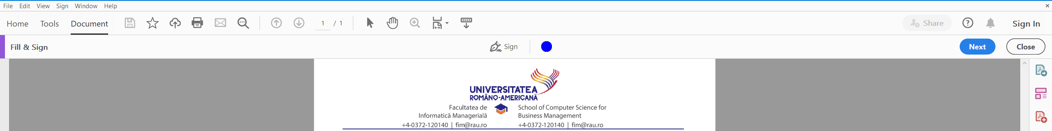
2
1

- Choose Add Signature.
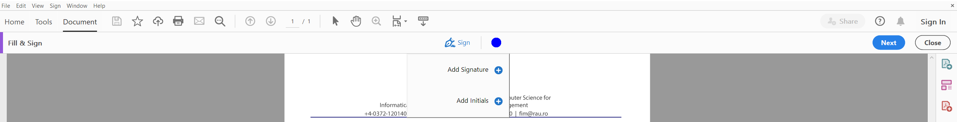

- Chose Draw [1], draw your signature inside the dedicated area [2], click Apply [3]. Pay attention to the Save signature [4] option – if you work on a trusted device, you can keep it checked and the signature drawing will be available for later usage too, if you do not wish the signature drawing to be saved uncheck.
1
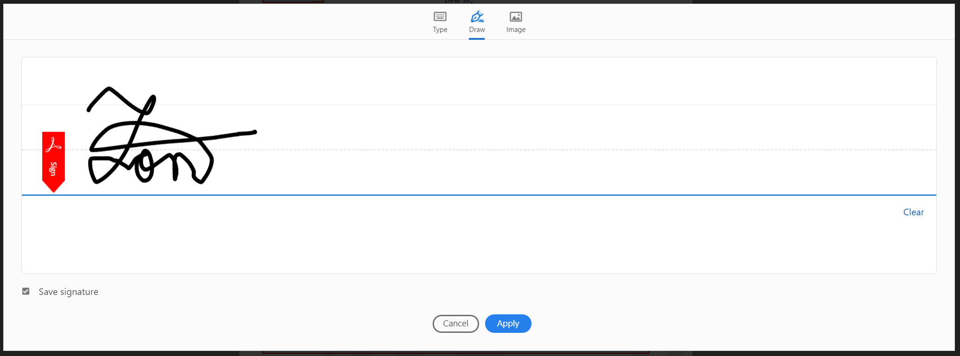
4
3
2
Alternatively, you can click on Image [5], select an already saved image of your signature (preferably in a transparency enabled file type, such as PNG) and use it.

- After applying your signature, you have to place it inside the PDF (usually inside a signature dedicated space). To move the placed signature, click the field to highlight it and then use the arrow keys (or select with your mouse/finger and drag it). To resize the field, select it and use the options from the field toolbar, or drag the lower-right marker. To delete the field, select it and press Delete on your keyboard or use the option from the field toolbar.

For more information on filling Adobe PDF forms please check:
https://helpx.adobe.com/acrobat/using/fill-and-sign.html#fill_your_PDF_form

